Electrochemical synthesis of ion exchange polymers: comparison between hydroxide and proton conductors

M. L. Di Vona^{1,3*}, P. Knauth^{2 ,3}
¹ Univ. Rome Tor Vergata, Dip. Ing. Industriale, Via del Politecnico, 00133 Roma, Italy
²Aix Marseille Univ, CNRS, MADIREL (UMR 7246), Campus Etoile-St Jérôme, 13013 Marseille, France
³ International Associated Laboratory (L.I.A.) “Ionomer Materials for Energy”, Aix Marseille Univ, CNRS, Univ. Rome Tor Vergata

Abstract
We report the electrochemical synthesis of proton- and hydroxide-conducting ionomers. Sulfonated poly(phenyl ether) with various degree of functionalization was synthesized starting from a precursor isomer mixture or from pure ortho- or para-hydroxybenzenesulfonic acid. The ionic conductivity can be related to the different ion exchange capacity of the ionomers. Two hydroxide-conducting ionomers were prepared from (N-allyl-N-benzyl-N,N-dimethyl)ammonium iodide (ABDMA) or N-(p-vinylbenzyl)-N,N,N-trimethylammonium chloride (VBTMA). The ionic conductivity of VBTMA polymer is two orders of magnitude higher than that of ABDMA. This result can be explained by the different structure of the two polymers, which changes the ion mobility drastically. The electrochemical synthesis of ionomers is a promising research field, where many advances can be made by clever choice of highly functionalized precursor monomers with appropriate positions of the ionic groups.

*Corresponding author: divona@uniroma2.it

Keywords: electrochemical polymerization, proton exchange membranes, anion exchange membranes, thin film
1. Introduction

Ion exchange polymers are fascinating materials with a wide range of applications, including to name but a few, electrochemical energy storage and conversion [1-4], water purification by ultrafiltration or electrodialysis [5-7], or sensors and actuators [8, 9]. In ionomers, a nanophase separation is generally observed with hydrophobic domains containing the ionomer backbone (often perfluorinated aliphatic [10-12] or aromatic hydrocarbon chains [13-17]) and nanometric channels containing the dissociated ions and a solvent with high dielectric constant, typically water [18-20]. The interface between the two domains contains the anchored ionic groups (such as sulfonate anions for proton-conducting ionomers or ammonium cations for hydroxide-conducting ionomers).
Proton [21, 22] and hydroxide [23, 24] conducting ionomers are particularly important as separation membranes for hydrogen fuel cell applications [25, 26]. To be useful, such membranes must fulfil many requirements, including a high mechanical stability [27, 28], means high stiffness and sufficient ductility, and a good chemical stability, for hydroxide-conducting ionomers especially a good stability against OH⁻ ions, which tend to attack the grafted ammonium groups [29-31]. These prerequisites should enable a high durability [32] under fuel cell operation conditions. However, the prime requirement for a good ionomer membrane is a low Area Specific Resistance (ASR).
There are two strategies to reduce the Area Specific Resistance (ASR) and increase the performances of solid electrolyte devices: the first is to increase the ionic conductivity and the second is to reduce the thickness of the ionomer separator. Many authors have worked on the improvement of the ionic conductivity of ionomers. Two main ways of improvement can be followed: i) augment the ion concentration, ii) augment the ion mobility. The ion concentration can be increased by synthesis of ionomers with higher ion exchange capacity [33, 34], means higher density of ionic groups or lower mass of the backbone. Furthermore, a better dissociation of ionic groups or ion pairs also improves the mobile ion concentration [35]. The ion mobility has been studied especially in proton-conducting ionomers [36-39]. Our own work shows that the ionic conductivity can be significantly enhanced by optimisation of the hydration conditions and using the memory effect of ionomers [40-42].
A reduction of the ionomer separator thickness requires finding a technique, which can deposit a continuous, pore-free layer with good reproducibility even for a very low thickness. Self-limiting conditions of formation can be particularly attractive, because they guarantee a good reproducibility of the separator thickness. Although physical vapour deposition techniques have been successfully developed for inorganic solid ion conductors [43, 44], they are difficult to implement for ionomers, although some reports have been published [45].
In this work, we show that the electropolymerisation can be a very attractive technique for the synthesis of thin ionomer separators. Electrodeposition techniques have been developed for various polymers [46-50], including copolymer electrolytes [51-53]; it is here used for the first time for ionomers.
The advantages of electropolymerisation include: i) thin deposition (self-limiting process), ii) high IEC (100% functionalization of the monomers is possible), iii) conformal deposition (even on complicated electrode geometries, like nanotubes [51]), iv) flexible and adjustable by changing the electrochemical parameters, v) fast, economical and scalable process.
Electropolymerisation can be made under anodic (oxidizing) or cathodic (reducing) conditions, depending on the precursor monomer and the electrode type. On metallic electrodes, both anodic and cathodic electrodeposition are possible; on semiconductors, it depends on the majority dopant type and illumination can be used. Figure 1 shows some electropolymerizable monomers: whereas phenol derivatives can be polymerized under anodic conditions with formation of ether-linked macromolecular chains, styrene and allylbenzene derivatives can be polymerized under anodic as well as cathodic conditions, due to the attack of the double bond, giving aliphatic chains with pendant phenyl groups. The ionomeric groups, such as sulfonic acid or ammonium groups, are typically grafted on the aromatic rings, where they can be introduced in the monomers for example by electrophilic aromatic substitution (sulfonic acid) or by chloromethylation followed by amination (ammonium).
We will present in the following the electrosynthesis of a proton-conducting ionomer, sulfonated poly(phenyl ether) (SPPE), and two hydroxide-conducting ionomers, poly(allyl benzyl dimethyl ammonium) chloride (ABDMA) and poly(vinyl benzyl trimethylammonium) chloride (VBTMA).
Figure 1. Some appropriate monomers for the electropolymerisation of proton- and hydroxide-conducting ionomers.

2. Experimental

2.1. Precursors for sulfonated poly(phenyl ether) (SPPE)

Isomer mixture
Phenol (Sigma–Aldrich) and concentrated sulfuric acid (98%, Fisher Science) were used as received without further purification. Sulfonated phenol (isomer mixtures) was prepared by dissolving 4.7 g phenol (0.05 mol) in concentrated sulfuric acid (10 mL, about 0.2 mol) and stirring at room temperature for 3 h. The obtained solution was diluted to 1 L and directly used for the electropolymerization.

Pure isomers
o-hydroxyphenylsulfonic acid: phenol reacted in 10 M sulfuric acid at 20 °C for 1.5 h. These conditions (low temperature, short time, high concentration) gave pure o-isomer.
p-hydroxyphenylsulfonic acid: the reaction was made in 2.5 M sulfuric acid at 100 °C for 3 h. 100% p-isomer was obtained using higher temperature, longer time, lower concentration.
After reaction, the solutions were neutralized by sodium hydroxide and the precipitates filtered, washed rapidly with cold ethanol and dried at 60 °C for 24 h.

2.2. Precursors for ionomers containing quaternary ammonium groups

N-(p-vinylbenzyl)-N,N,N-trimethylammonium chloride (VBTMA) was purchased from Sigma Aldrich (99%).
Synthesis of (N-allyl-N-benzyl-N,N-dimethyl)ammonium iodide (ABDMA)
(N-allyl-N-benzyl)amine (5 mmol, 96 %, TCI) was dissolved in ethyl acetate (25 mL, Aldrich, ACS grade). Iodomethane (1.55 mL, 25 mmol, 97 %, Aldrich) and anhydrous potassium carbonate (3.45 g, 25 mmol, Aldrich) were added and the mixture was stirred for 20 hours at room temperature.
The reaction mixture was filtered and washed with ethyl acetate (2 x 25 mL). The solid was dissolved in ethanol (100 mL), the excess of potassium carbonate filtered and the residual solvent was evaporated (2 mbar, 50 °C). This purification procedure was repeated twice.

2.2. Electropolymerization

The electropolymerization reactions were studied by Cyclic Voltammetry (CV) and chronoamperometry using a potentiostat/galvanostat (BioLogic VP300) and a conventional three-electrode cell. The counter electrode was a Pt sheet facing a glassy carbon or stainless steel working electrode. A saturated Ag/AgCl electrode was used as reference; all potentials are referred to it. All experiments were carried out at room temperature and atmosphere.
For proton exchange polymers, the CV was performed in an anodic potential range between 0.7 and 1.4 V with a scan rate of 20 mV/s and the chronoamperometric tests at a constant voltage of 1.3 V. For the electropolymerization from pure isomers, 0.05 M solutions were prepared with H₂SO₄ (0.2 M) as supporting electrolyte. The diluted sulfonation medium containing sulfuric acid was directly used for the electropolymerization from the isomer mixture (see above).
For anion exchange polymers, after many preliminary tests, the best results were obtained on glassy carbon with a dimethylsulfoxide (DMSO) solution containing 10⁻³ M of VBTMA or ABDMA precursor and 0.25 M of LiClO₄. CV was typically performed in a cathodic potential range between -1.0 and -2.1 V vs. Ag/AgCl with a scan rate of 20 mV/s.

2.3. Characterization

¹H NMR spectra were recorded with a Bruker Avance 400 spectrometer operating at 400.13 MHz. Chemical shifts (ppm) are referenced to tetramethylsilane (TMS). FTIR spectra were observed using a Perkin Elmer instrument. Electrochemical Impedance Spectroscopy (EIS, BioLogic VP300) measurements of the cell were performed before and after the electropolymerisation. The impedance spectra were recorded between 1 Hz to 1 MHz with an oscillating voltage amplitude of 20 mV. The thickness of the ionomer layer was determined using a micrometer (Mitutoyo IP65).

3. Results

3.1. Electropolymerization of proton-conducting ionomer: SPPE

Figure 2 shows typical cyclovoltammograms of the electropolymerisation of SPPE from pure o- and p-hydroxybenzenesulfonic acid [54]. In order to avoid anodic side reactions, especially the oxygen evolution reaction (OER), the anodic potential range was kept below 1.4 V vs Ag/AgCl, where OER should not occur in aqueous media, and acidic conditions were applied, which increases the Nernst potential.
The decrease of the current density with the cycle number is due to the increase of the electrode resistance by the formation of the resistive continuous SPPE layer. The ionomer electrodeposition is thus a self-limiting process giving thin ionomer separators. One notices a much larger current density for the o-isomer, which can be related to the polymerisation mechanism (see below).

Figure 2. Cyclovoltammograms of the electropolymerization of SPPE from pure o- or p-isomers on glassy carbon. The cycle numbers are indicated.

The electropolymerisation from an isomer mixture (60 % p-isomer, 20 % o-isomer, 20 % unsulfonated phenol) gave a peak current density between 0.3 (steel) and 0.4 mA/cm² (carbon) [55]. The peak current density for the isomer mixture on carbon is in good agreement with the value calculated using the peak current densities of the pure isomers from Figure 2 and the concentrations of the two isomers in the mixture. The dependence on the electrode material emphasizes the importance of the interfacial bonds between the electrode and the ionomer, which modifies the overpotential for the deposition.
Figure 3 shows a comparison of NMR spectra of two SPPE polymers obtained starting from a sulfonated phenol isomer mixture (Fig. 3a) and from pure o-precursor (Fig. 3b). The peaks are slightly shifted due to the use of different solvents. Both spectra show the typical pattern of tri-substituted phenyl rings with peaks due to the hydrogen atom singlet (A and B signals) on the aromatic ring bearing sulfonic groups, indicating the occurrence of the polymerization reaction in the activated positions. The spectrum 3a also shows the different products (o and p-polymers) obtained starting from the phenol reaction mixture.

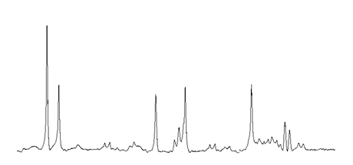
a)
A
B
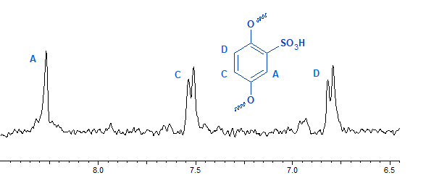
b)
ppm
Figure 3. ¹H NMR spectra of SPPE obtained by electropolymerization from a) phenol sulfonation reaction mixture (DMSO-d₆), b) pure o-hydroxybenzenesulfonic acid (D₂O)

The spectrum 3b indicates that the polymerization of the pure o-isomer leads principally to the linear sulfonated p-poly(phenyl ether), as shown by the presence of three main signals A, B, and C at 8.3, 7.5 and 6.8 ppm. Other minor peaks in the spectrum at 7.6 and 6.9 ppm are probably due to a low quantity of o-polymerization leading to some branching (sulfonated p and o-poly(phenyl ether)).

Figure 4. Mechanism of the electropolymerization of SPPE from a) pure o-precursor b) pure p-precursor and from c) precursor mixture.

The linear SPPE appears sterically clearly favoured, which probably explains its easier formation and the higher current densities observed in Figure 2.

3.2. Electropolymerization of hydroxide-conducting ionomers

Figure 5 shows typical cyclovoltammograms corresponding to the electropolymerisation of ABDMA and VBTMA [56]. In order to avoid as much as possible the hydrogen evolution reaction (HER) in cathodic conditions, the amount of protons was limited as much as possible. The deposition was therefore made under dry nitrogen and in presence of Li salt as supporting electrolyte.
The peak current density decreases with the cycle number due to the formation of a continuous resistive ionomer layer. The cathodic current density is much larger for VBTMA than for ABDMA showing an easier polymerisation mechanism for the former. In cathodic conditions, the polymerization starts by the reduction of the vinylic or allylic double bond with formation of a radical anion, which is stabilized by mesomeric effect with the phenyl group for VBTMA. This resonance is not possible in ABDMA, because it is interrupted by the ammonium group [56].

Figure 5. Cyclovoltammograms of the electropolymerization of ABDMA and VBTMA on glassy carbon.

¹H NMR spectra of electropolymerized ABDMA and ABDMA monomer help to establish the electropolymerization mechanism and the ionomer structure. Note the disappearance of the signals of protons associated to the double bond after polymerization. In the spectrum of the precursor (Fig. 6a), one can distinguish the characteristic signals of the allyl system (A, 5.8 ppm and B, 5.9 ppm), where the terminal protons experience a different magnetic environment. The signal C (4.4 ppm) is due to the methylene group between ammonium and double bond moieties, whereas the singlet of the methylene group between ammonium and phenyl moieties is shifted to lower field (E, 5.1 ppm). The other signals correspond to the N-methyl protons (D, 3.0 ppm) and to the aromatic protons (F,G,H, 7.5 ppm). The spectrum of electrodeposited ABDMA (Fig. 6b) displays a very different pattern with broad peaks typically observed in a polymer. New peaks due to aliphatic polymer main chain protons appear in the high field region (A, 1.6 ppm and B, 0.9 ppm), while signals C and E, ascribed to methylene groups both near the ammonium atom, are centred at 4.8 ppm. N-methyl protons (D, 3.2 ppm) and aromatic protons (F,G,H, centred at 7.6 ppm) show similar chemical shifts with those observed in the case of the precursor. The signal I (0.7 ppm) can be ascribed to the terminal methyl group. From the ratio of its area and the area of aromatic protons (5H), it is possible to estimate a chain length of 30 repeat units that correspond to an average molecular weight of around 5300 g/mol.
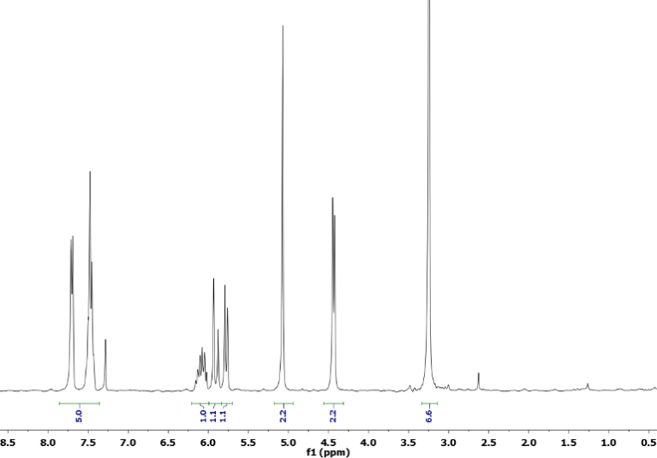
a)
F,G,H
B
A
E
C
D
*

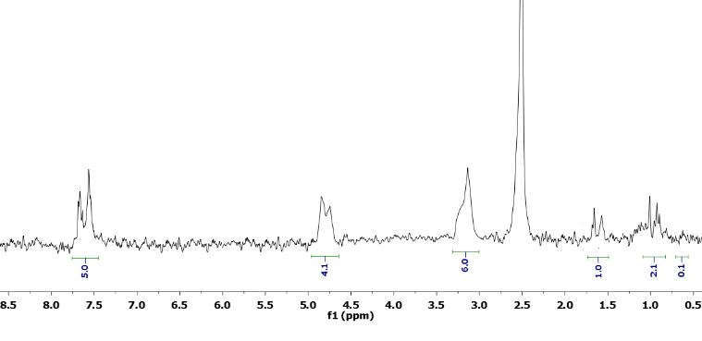
b)
F,G,H
E,C
D
A
B
*
I

Figure 6. ¹H NMR spectra (DMSO-d₆) of a) ABDMA precursor; b) electropolymerized ionomer.

Figure 7 shows the FTIR spectrum of electropolymerized VBTMA. The peak assignments in Table 1 reveal the absence of signals around 1630 cm⁻¹ due to the styrene moiety, which are present in the starting material, confirming the formation of the polymer.

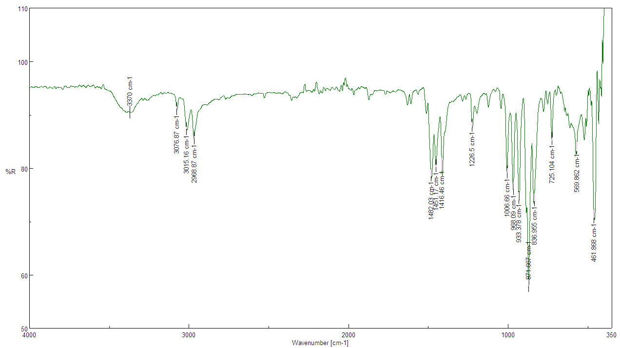
Figure 7. FTIR spectrum of electropolymerized VBTMA.
Table 1. Peak assignments of FTIR spectrum of electropolymerized VBTMA.

Wavenumber (cm⁻¹) | Assignments [57-59]
3370 | OH stretching
3077 | CH stretching, aromatic
3015 | CH stretching, quaternary ammonium
2969 | CH₃ stretching, quaternary ammonium
1482 | C-N asymmetric stretching +  aliphatic CH₂ bending (scissoring)
1452 | CH₂ bending (polymer) +  C=C bending aromatic ring
1416 | CH₂ bending quaternary ammonium
1226-1007 | CH aromatic in-plane bending
968-933 | C-H aromatic out of plane bending +  C-N asymmetric stretching
871 | C-H out of plane bending di-substituted aromatic ring
836 | C-H aromatic out-of plane
725 | CH₂ aliphatic rocking

4. Discussion

4. 1. Ionic conductivity

In general, one ion predominates the ionic conductivity of a solid. In ionomers, the transference number of the mobile ions is near unity, because the counter-ions are anchored on the macromolecular chain. The ionic conductivity σ can be written as a product of the ion charge q_{i}, the ion concentration c_{i} and the ion mobility u_{i}.[60]
$σ=q_{i}c_{i}u_{i}$ (1)
In ionomers, the ion concentration is related to the ion exchange capacity (IEC), but the degree of dissociation of the ionic groups and the formation of ion pairs must be taken into account. The latter is also related to the so-called Manning condensation [61], which limits the density of ionisable groups in a polyelectrolyte. Below a certain average distance (very similar to the association distance in the Bjerrum theory, typically below 1 nm [62]), the ionic groups do not dissociate. The ion mobility is related to several factors, including solvation (especially hydration in aqueous solutions), the size and tortuosity [63], [64] of the ion conduction network and its percolation threshold [14, 42, 65]. The latter factors are determined by the nanophase separation between hydrophobic and hydrophilic domains in the ionomer [66-68].
In the outlined electrochemical synthesis, the ion concentration can be tuned using precursors with various degrees of functionalization. For SPPE, the degree of sulfonation (DS) can be varied between 1 (for fully sulfonated o-precursor isomer) to about 0.6 (for the precursor mixture, containing about 20 % unsulfonated phenol and 20 % p-precursor that polymerizes slowly).
Assuming that the sulfonic acid groups are fully dissociated, one can expect an about double proton conductivity for the fully functionalized SPPE: the experiment verifies this expectation (σ(DS = 1) = 6 mS/cm [54], σ(DS = 0.6) = 3 mS/cm [69]).
The effect of the ion mobility can be very impressively observed in the hydroxide-conducting ionomers made by electrochemical synthesis [56]. Although ABDMA and VBTMA polymers were made with fully functionalized precursors, the hydroxide ion conductivity of VBTMA is about two orders of magnitude higher (σ(VBTMA) = 3 mS/cm, σ(ABDMA) = 0.03 mS/cm) emphasizing the importance of the position of ionic groups on the aromatic ring (ABDMA and VBTMA monomers are isomers!). To understand this result, we must have a look at the ionomer structures, shown in Figure 8. Here, we observe that while the ammonium groups are aligned on the outside of the macromolecular chains of VBTMA, they are instead placed in sterically unfavourable positions in ABDMA. One can foresee that the former structure facilitates the nanophase separation and reduces the percolation threshold and the tortuosity of the conduction network. Another factor influencing the ion mobility is the hydration: we have studied the enhancement of the ion mobility by better hydration both for proton- [41] as well as for anion-conducting [70] ionomers. It will be the subject of further investigations for electrochemically prepared ionomers.

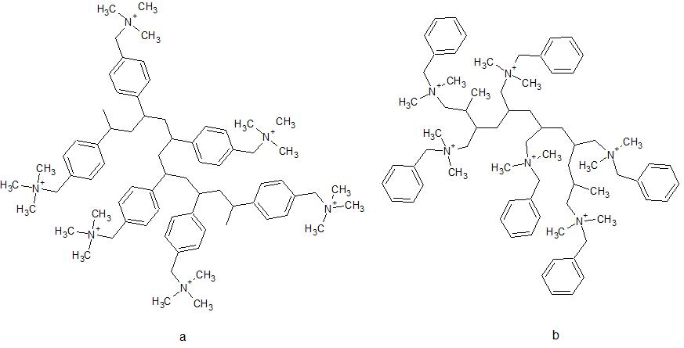
Figure 8. Ionomer structures: a) VBTMA and b) ABDMA.

4. 2. Outlook on other ions: lithium ion-conducting polymers

The electrochemical synthesis of ionomers is obviously not limited to proton and hydroxide-conducting materials, but other ions can be explored using appropriate precursors or performing the electrosynthesis in the presence of the desired ions, which can be added to the supporting electrolyte.
We have successfully attempted the electrodeposition of Li ion-conducting polymers on nanostructured electrodes, including sulfonated poly(allyl phenyl ether) (SPAPE [71]) and poly(styrene sulfonate) (PSS [72]). The microbattery tests showed performances among the best in literature in terms of both specific energy and power densities.

5. Conclusions

Eletropolymerization of ionomers is an innovative method for the preparation of thin, conformal and highly functionalized ion-conducting separators. In this work, we present the electrosynthesis of a proton-conducting polymer, sulfonated poly(phenyl ether) (SPPE), and hydroxide-conducting polymers, poly(allyl benzyl dimethyl ammonium) hydroxide (ABDMA) and poly(vinyl benzyl trimethylammonium) hydroxide (VBTMA). The ion conductivity can be enhanced by a high degree of functionalization, leading to a high ion exchange capacity. The ion mobility, which is related to the percolation threshold and tortuosity of the ion-conducting channel network, can be enhanced by a better nanophase separation, related to the position of the ionic groups. Other ion-conducting separators can be prepared by clever choice of the ionic groups or by adding the desired ions to the supporting electrolyte.

References

[1] K.D. Kreuer, Chem. Mater. 26 (2014) (1) 361.
[2] G. Nawn, K. Vezzu, G. Cavinato, G. Pace, F. Bertasi, G. Pagot, E. Negro, V. Di Noto, Adv. Funct. Mater. 28 (2018) (29) 10.
[3] J.R. Varcoe, P. Atanassov, D.R. Dekel, A.M. Herring, M.A. Hickner, P.A. Kohl, A.R. Kucernak, W.E. Mustain, K. Nijmeijer, K. Scott, T.W. Xu, L. Zhuang, Energy & Environmental Science 7 (2014) (10) 3135.
[4] P.N. Pintauro, Polymer Reviews 55 (2015) (2) 201.
[5] Y. Tanaka, Industrial & Engineering Chemistry Research 50 (2011) (12) 7494.
[6] W. Wang, R. Fu, Z. Liu, H. Wang, Desalination 417 (2017) 1.
[7] R.A. Tufa, S. Pawlowski, J. Veerman, K. Bouzek, E. Fontananova, G. di Profio, S. Velizarov, J.G. Crespo, K. Nijmeijer, E. Curcio, Applied Energy 225 (2018) 290.
[8] B. Adhikari, S. Majumdar, Progress in Polymer Science 29 (2004) (7) 699.
[9] T. Kwon, J.W. Lee, H. Cho, D. Henkensmeier, Y. Kang, S.M. Hong, C.M. Koo, Sensors and Actuators B-Chemical 214 (2015) 43.
[10] G. Gebel, Polymer 41 (2000) (15) 5829.
[11] S. Banerjee, D.E. Curtin, Journal of Fluorine Chemistry 125 (2004) (8) 1211.
[12] K.A. Mauritz, R.B. Moore, Chem. Rev. 104 (2004) (10) 4535.
[13] M. Rikukawa, K. Sanui, Progress in Polymer Science 25 (2000) (10) 1463.
[14] X.M. Wu, X.W. Wang, G.H. He, J. Benziger, Journal of Polymer Science Part B-Polymer Physics 49 (2011) (20) 1437.
[15] B. Bauer, D.J. Jones, J. Roziere, L. Tchicaya, G. Alberti, M. Casciola, L. Massinelli, A. Peraio, S. Besse, E. Ramunni, Journal of New Materials for Electrochemical Systems 3 (2000) (2) 93.
[16] C.H. Park, C.H. Lee, M.D. Guiver, Y.M. Lee, Progress in Polymer Science 36 (2012) (11) 1443.
[17] P. Knauth, E. Sgreccia, A. Donnadio, M. Casciola, M.L. Di Vona, Journal of the Electrochemical Society 158 (2011) (2) B159.
[18] M.A. Hickner, Journal of Polymer Science Part B-Polymer Physics 50 (2012) (1) 9.
[19] K.D. Kreuer, G. Portale, Adv. Funct. Mater. 23 (2013) (43) 5390.
[20] D.W. Shin, M.D. Guiver, Y.M. Lee, Chem. Rev. 117 (2017) (6) 4759.
[21] K.D. Kreuer, S.J. Paddison, E. Spohr, M. Schuster, Chemical Reviews 104 (2004) (10) 4637.
[22] G.A. Giffin, G.M. Haugen, S.J. Hamrock, V. Di Noto, JACS 135 (2013) (2) 822.
[23] G. Couture, A. Alaaeddine, F. Boschet, B. Ameduri, Progress in Polymer Science 36 (2011) (11) 1521.
[24] M.L. Di Vona, R. Narducci, L. Pasquini, K. Pelzer, P. Knauth, Int. J. Hydrogen Energy 39 (2014) (26) 14039.
[25] B. Smitha, S. Sridhar, A.A. Khan, Journal of Membrane Science 259 (2005) (1-2) 10.
[26] G. Merle, M. Wessling, K. Nijmeijer, Journal of Membrane Science 377 (2011) (1-2) 1.
[27] R. Narducci, J.F. Chailan, A. Fahs, L. Pasquini, M.L. Di Vona, P. Knauth, Journal of Polymer Science Part B-Polymer Physics 54 (2016) (12) 1180.
[28] E. Sgreccia, J.F. Chailan, M. Khadhraoui, M.L. Di Vona, P. Knauth, J. Power Sources 195 (2010) (23) 7770.
[29] B. Bauer, H. Strathmann, F. Effenberger, Desalination 79 (1990) (2-3) 125.
[30] H.S. Dang, P. Jannasch, Macromolecules 48 (2015) (16) 5742.
[31] B.L. Zhao, G.H. He, I. El Hamouti, L. Gao, Y.J. Liu, R.L. Deng, X.M. Yan, Int. J. Hydrogen Energy 42 (2017) (15) 10228.
[32] H.Y. Hou, M.L. Di Vona, P. Knauth, Chemsuschem 4 (2011) (11) 1526.
[33] K.D. Kreuer, M. Schuster, B. Obliers, O. Diat, U. Traub, A. Fuchs, U. Klock, S.J. Paddison, J. Maier, Journal of Power Sources 178 (2008) (2) 499.
[34] Schuster, A. de, Atanasov, Andersen, Kreuer, Maier, Macromolecules 42 (2009) (8) 3129.
[35] N.A. Stolwijk, M. Wiencierz, C. Heddier, J. Kosters, Journal of Physical Chemistry B 116 (2012) (10) 3065.
[36] A. Telfah, G. Majer, K.D. Kreuer, M. Schuster, J. Maier, Solid State Ionics 181 (2010) (11-12) 461.
[37] K.D. Kreuer, Solid State Ionics 136 (2000) 149.
[38] M. Saito, N. Arimura, K. Hayamizu, T. Okada, The Journal of Physical Chemistry B 108 (2004) (41) 16064.
[39] T.J. Peckham, J. Schmeissert, S. Holdcroft, Journal of Physical Chemistry B 112 (2008) (10) 2848.
[40] M.L. Di Vona, L. Pasquini, R. Narducci, K. Pelzer, A. Donnadio, M. Casciola, P. Knauth, J. Power Sources 243 (2013) 488.
[41] P. Knauth, L. Pasquini, B. Maranesi, K. Pelzer, R. Polini, M.L. Di Vona, Fuel Cells 13 (2013) (1) 79.
[42] P. Knauth, M.L. Di Vona, Solid State Ionics 225 (2012) 255.
[43] P. Knauth, Solid State Ionics 180 (2009) (14-16) 911.
[44] J.B. Bates, N.J. Dudney, B. Neudecker, A. Ueda, C.D. Evans, Solid State Ionics 135 (2000) (1-4) 33.
[45] H. Mahdjoub, S. Roualdes, P. Sistat, N. Pradeilles, J. Durand, G. Pourcelly, Fuel Cells 5 (2005) (2) 277.
[46] S. Aeiyach, P.C. Lacaze, Polymer 30 (1989) (4) 752.
[47] S. Aeiyach, P.C. Lacaze, Journal of Polymer Science Part a-Polymer Chemistry 27 (1989) (2) 515.
[48] U. Akbulut, J.E. Fernandez, R.L. Birke, Journal of Polymer Science Part a-Polymer Chemistry 13 (1975) (1) 133.
[49] J.W. Breitenbach, F. Sommer, G. Unger, Monatshefte Fur Chemie 107 (1976) (2) 359.
[50] S.L. Cram, G.M. Spinks, G.G. Wallace, H.R. Brown, Electrochimica Acta 47 (2002) (12) 1935.
[51] N.A. Kyeremateng, F. Dumur, P. Knauth, B. Pecquenard, T. Djenizian, Electrochem. Commun. 13 (2011) (8) 894.
[52] N. Plylahan, N.A. Kyeremateng, M. Eyraud, F. Dumur, H. Martinez, L. Santinacci, P. Knauth, T. Djenizian, Nanoscale Research Letters 7 (2012) 1.
[53] N. Plylahan, S. Maria, T.N.T. Phan, M. Letiche, H. Martinez, C. Courreges, P. Knauth, T. Djenizian, Nanoscale Research Letters 9 (2014) 8.
[54] M. Braglia, I.V. Ferrari, F. Vacandio, P. Knauth, M.L. Di Vona, Chemistryselect 1 (2016) (12) 3114.
[55] H.Y. Hou, F. Vacandio, M.L. Di Vona, P. Knauth, Journal of Applied Polymer Science 129 (2013) (3) 1151.
[56] M. Braglia, I.V. Ferrari, L. Pasquini, T. Djenizian, M. Sette, M.L. Di Vona, P. Knauth, Electrochimica Acta 265 (2018) 78.
[57] J. Coates, In: R.A. Meyers, Editor, Encyclopedia of Analytical Chemistry, John Wiley & Sons Ltd (2006), p.10815–10837.
[58] V.M. Zolotarev, Opt. Spectrosc. 122 (2017) (5) 749.
[59] M.L. Di Vona, M. Casciola, A. Donnadio, M. Nocchetti, L. Pasquini, R. Narducci, P. Knauth, Int. J. Hydrogen Energy 42 (2017) (5) 3197.
[60] C.H. Hamann, A. Hamnett, W. Vielstich, Electrochemistry, Wiley-VCH, Weinheim (2007).
[61] G.S. Manning, Accounts of Chemical Research 12 (1979) (12) 443.
[62] R.M. Fuoss, Journal of the American Chemical Society 80 (1958) (19) 5059.
[63] N. Epstein, Chemical Engineering Science 44 (1989) (3) 777.
[64] M.P. Rodgers, Z.Q. Shi, S. Holdcroft, Journal of Membrane Science 325 (2008) (1) 346.
[65] A. Bunde, W. Dieterich, E. Roman, Physical Review Letters 55 (1985) (1) 5.
[66] G. Gebel, Macromolecules 46 (2013) (15) 6057.
[67] S.J. Paddison, Annual Review of Materials Research 33 (2003) 289.
[68] Y.S. Yang, A. Siu, T.J. Peckham, S. Holdcroft, Fuel Cells I 215 (2008) 55.
[69] H.Y. Hou, F. Vacandio, M.L. Di Vona, P. Knauth, Electrochimica Acta 81 (2012) 58.
[70] L. Pasquini, M.L. Di Vona, P. Knauth, New Journal of Chemistry 40 (2016) (4) 3671.
[71] I.V. Ferrari, M. Braglia, T. Djenizian, P. Knauth, M.L. Di Vona, Journal of Power Sources 353 (2017) 95.
[72] M. Braglia, I.V. Ferrari, T. Djenizian, S. Kaciulis, P. Soltani, M.L. Di Vona, P. Knauth, Acs Applied Materials & Interfaces 9 (2017) (27) 22902.

